**Moral Values and Attribution to Person or Situation**

*Analyses*

(H1) **We expect people who more highly endorse “binding” values to judge agents of moral violations to have acted due to their character (internal attributions) rather than the situation (external forces).** One possible explanation for this effect is that it’s driven by people higher in binding values being more motivated to considered others contaminated when they violate group norms (Niemi & Young, 2016). This would predict that people higher in binding values should consider violators to be internally-motivated regardless of whether the violator shares their moral values or not. **Thus, we should observe the relationship between binding values and person attributions across the range of moral violations (harm, unfairness, disloyalty, disobedience, and impurity).**

(H2) **A second possibility is that people consider violations that they personally consider very wrong to be more character-driven (i.e., people high in binding values attribute binding violations to the person not situation**). If this alternative is borne out, it would suggest that person-based attributions increase people’s capacity to maintain moral-value-specific group boundaries.

(H3) Moreover, it is possible that we will observe within-persons differences based on the type of moral violation. **People may make more person attributions about binding violations, and situation attributions about care/fairness violations**. This may occur with an **interaction** such that those dispositionally high in binding values will be especially likely to judge binding violations as driven by character.

(H4) Finally, if binding values (typically higher in conservatives) are associated with attributing deeds to the person rather than the situation when we **control for political orientation**, this will support a general tendency for attributional preferences to vary based on moral values rather than political ideology.

***Study 1****.*

**Method.**

*Participants (Study 1).*A total of 296 participants (female = 165, male = 131) on Amazon Mechanical Turk completed the study after 82 exclusions**[1]**.

*Participants (Study 2).*A total of 315 participants (female = 113, male = 199, other = 3) on Amazon Mechanical Turk completed the study after 18 exclusions**[2]**.

*Materials (Study 1 and Study 2).*Participants completed the 30-item Moral Foundations Questionnaire (MFQ) either before or after viewing a series of short vignettes involving moral violations (each viewed two of four possible vignettes, from each of the foundations i.e., 10 total vignettes; see Appendix; Clifford, Iyengar, Cabeza, & Sinnott-Armstrong, 2015).

For each vignette, participants answered a series of questions to measure their attributions.

Four items used Likert-scale responses of agreement: [“Strongly disagree”, “Disagree”, “Somewhat disagree”, “Neither agree nor disagree”, “Somewhat agree”, “Agree”, “Strongly agree”].

1. ***TYPE****:* A person is either the type to do this, or to never do this.
2. ***SITUATIONS****:* There are situations that could lead a person to do this.
3. ***WRONG****:* What happened was wrong.
4. ***RESPONSIBLE****:* [The person] is responsible for what happened.

One item used a sliding-scale with 20-point increments. This item was the primary measure of person-situation attribution in analyses.

1. ***CAUSE****:* This was caused more by:

The situation The person

-100 -80 -60 -40 -20 0 20 40 60 80 100

**Results**

*H1. (Study 1).*We first asked: Do participants who more highly endorse “binding” values judge violators to have acted due to their *character* (internal attributions) rather than the *situation* (external forces)? We then asked: Do participants higher in binding values judge agents of *binding violations* to be more character-driven, or violators in general to be more character-driven?

To examine this question, we first ran correlational analyses between binding values and ratings of CAUSE, overall. We then ran correlational analyses between binding values and ratings of CAUSE for binding violations, and CAUSE for individualizing violations, separately.

**Results showed that people higher in binding values in fact considered binding violations more person-caused (*r=.225, p<.*00009), but did not consider individualizing violations more person-caused (*r=.*064, *p=.*28).**

[This correlation was driven by loyalty and authority values. Loyalty values were correlated with rating loyalty violations as more likely to be caused by “the person” rather than “the situation” (*r*=.233, *p*=.000051); likewise, authority values were correlated with rating authority violations as more likely to be caused by “the person” rather than “the situation” (*r*=.235, *p*=. 000044). Purity values were uncorrelated with ratings of causation for purity violations (r=.085, *p*=.144).]

**Likewise, people higher in individualizing values considered individualizing violations to be more person-caused (*r=.*147, *p=.*01), but did not consider binding violations more person-caused (*r=.*055, *p=.*35).**

[This correlation was driven by harm values. Harm values were correlated with rating harm violations as more likely to be caused by “the person” rather than “the situation” (*r*=.229, *p*=.00007); fairness values were uncorrelated with ratings of the causation of fairness violations (*r*=-.001, *p*=.98).]

*H2.* *(Study 1).* The above findings support H2: “**Person-based attributions for moral violations increase people’s capacity to maintain moral-value-specific group boundaries.”**

*H3.* *(Study 1).* We asked if people generally tend to attribute violations in the binding domains to the person, and whether this within-persons tendency interacts with disposition such that the tendency is exacerbated in those high in binding values.

To test this we first ran three repeated measures ANOVAs on participants’ judgments of (a) CAUSE, (b) TYPE, and (c) SITUATION. Interestingly, **there was no general within-persons tendency to attribute binding violations (authority, ingroup loyalty, purity) to the person, and individualizing violations (harm and fairness) to the situation.** We then analyzed (d) WRONGNESS, and (e) RESPONSIBILITY ratings in the same way. See analyses and graphs next.

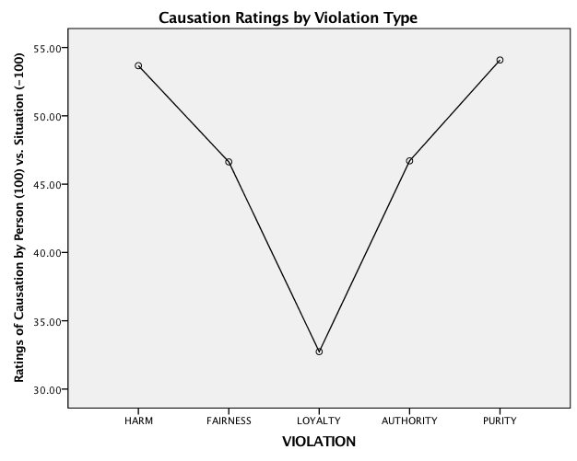CAUSE. Attributions were equally and most highly “person-based” for harm *and* purity violations (*M’s=*53.7, 54.1, *F(*1,295)=.01, *p=.*92).

Purity violations were considered more person-based than bothfairness and authority violations which were also equivalent (*M’s=*46.6, 46.7, *F(*1,295)=6.2, *p=.*01; *F(*1,295)=6.9, *p=.*01, respectively).

Loyalty violations were considered significantly less person-based than the other kinds of violations (*M=*32.7, all comparisons *p’*s <.001).

TYPE. The pattern of judgments of whether a person is “the **type** to do the violations” corresponded with CAUSE ratings (except for *harm*).

SITUATIONS. Judgments that there are “**situations** that could lead a person to do this” were essentially flipped “CAUSE” ratings, with purity violations the least situation-based, significantly different from all other violation types (*p>.*05).

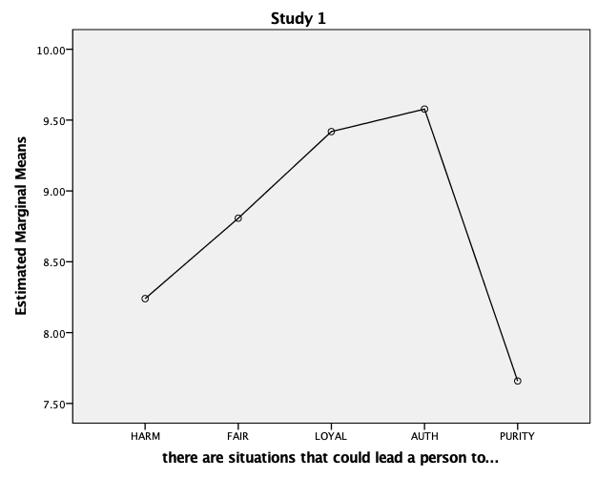

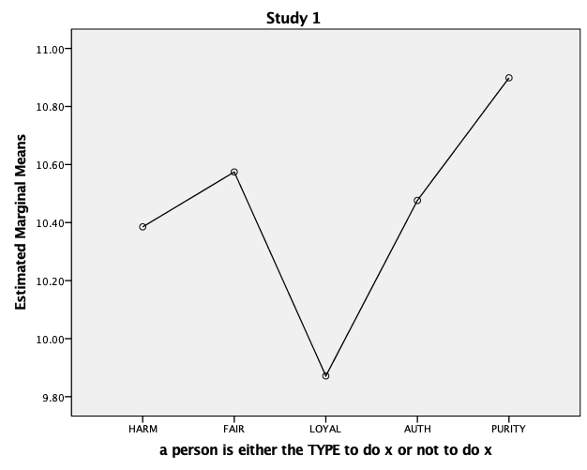

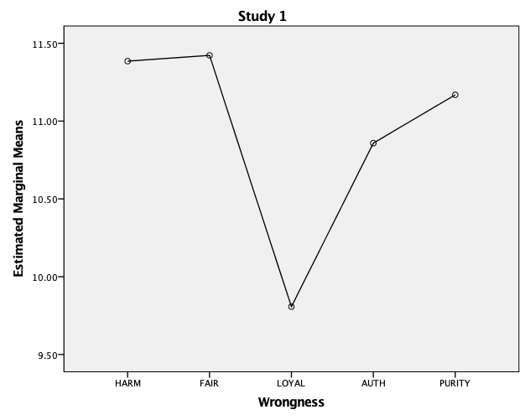

WRONGNESS. Judgments of **wrongness** looked very close to judgments of type. Harm and fairness violation wrongness was identical, and both were not statistically different from purity violation wrongness (*p’*s >.71). Authority was not statistically different from purity violations (*p =* .29). Loyalty violations was less wrong than the other violations (*p’*s <.001). These results support a link between wrongness and “type”-based attributions--“type”-based attributions may support strong wrongness beliefs.



RESPONSIBILITY. Responsibility attributions demonstrated roughly the same pattern, except people did not attribute as much **responsibility** to fairness violators compared to patterns in their other judgments, e.g., wrongness ratings. Responsibility ratings *did*pattern with person-cause ratings for the other foundations.

PS. Sprry about the change in responsibility chart, my variable was mis-coded!

INTERACTION WITH DISPOSTION. We next tested whether a within-persons tendency might interact with disposition. We used a repeated measures ANOVA on participants’ judgments of CAUSE w/ participants’ binding values as the between-subjects variable (High/low median split). The **interaction was significant** (*F*(4,1176)=3.36, *p=*.01). Follow-up test showed that **judgments of CAUSE differed for two of the binding violations: *loyalty*** (low binding *M=*22, high binding *M=43, t*(294)=-4.34, *p<.*001; ***authority*** (low binding *M*=37, high binding *M=*56, *M=43, t*(294)=-4.54, *p<.*001, **between people high and low in binding values, confirming this hypothesis**.

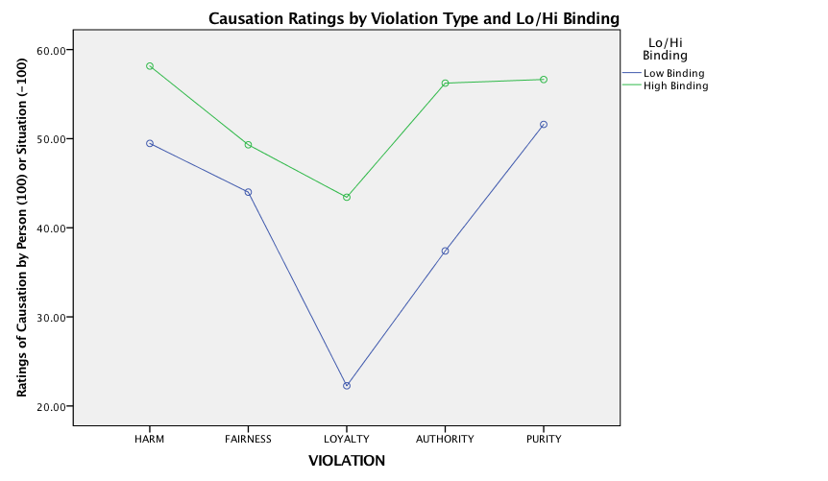

*H4. (Study 1).* We tested whether our results were explained by politics. Partial correlations (n=274) controlling for political orientation (very liberal = 1, very conservative = 7) showed that **controlling for politics** **binding values remained associated with person-CAUSE for binding violations** (*r*= .144, *p=*.016), **and uncorrelated with person-CAUSE for individualizing violations** (*p=*.087). Controlling for politics (n=274), individualizing values remained correlated with person-CAUSE for individualizing violations (*r*= .150, *p=*.012). Individualizing values became correlated with CAUSE for binding values, controlling for politics (*r*= .135, *p=*.025). These results suggest that independent of politics, binding values inform causal attributions about binding violations, and also that individualizing values generally inform causal attributions about moral violations.

**SEVERITY & FREQUENCY CHECK**

*Q. Do severity and frequency pre-ratings account for the key result?*

*I ran 2 regression analyses to predict causal attributions of (1) Binding and (2) Individualizing violations to the “person” rather than the “situation”. In the first step of these, I entered participants’ (1) Binding, or (2) Individualizing values MFQ scores as in the correlational analyses. In the second and third steps, I entered the (2) Severity and (3) Frequency ratings for the Binding or Individualizing items they saw.*

*In the case of Binding values, Severity and Frequency did not factor into the relationship between participants’ Binding values and their tendency to attribute binding violations to the “person”. The relationship remained significant (p=.0001), and both Severity and Frequency were unrelated to cause judgments (p>.35).*

*Causal attribution to “person” or “situation” for harm was related to frequency of Harm items, (Beta = .212. p = .001) -- but not severity.*

***Study 2.***

***(Abandoned attempts at gender balancing, etc in vignettes) ensured much more closely matched severity and frequency.***

**Method.**

*Participants (Study 2).*A total of 315 participants (female = 113, male = 199, other = 3) on Amazon Mechanical Turk completed the study after 18 exclusions**[3]**.

*Materials (Study 2).*Identical to Study 1, but some vignettes were swapped out (still 10 total vignettes; see Appendix; Clifford, Iyengar, Cabeza, & Sinnott-Armstrong, 2015). Same questions after vignettes as Study 1.

**Results**

*H1. (Study 2).* Same questions: Do people who more highly endorse “binding” values judge violators to have acted due to their *character* (internal attributions) rather than the *situation* (external forces)? We then asked: Do participants higher in binding values judge agents of *binding violations* to be more character-driven, or violators in general to be more character-driven?

Results were nearly identical to Study 1: **people higher in binding values considered binding violations more person-caused (*r=.*257*, p<.*000004), but did not consider individualizing violations more person-caused (*r=-.*032, *p=.*58).**

[The correlation was driven by all three values this time: loyalty and authority values. Loyalty (*r*=.161, *p*=.004); authority (*r*=.265, *p*=.000002), purity (r=.259, *p*=.000003).]

Likewise, **people higher in individualizing values considered individualizing violations to be more person-caused (*r=.*186, *p=.*001), but did not consider binding violations more person-caused (*r=.*032, *p=.*57).**

[This correlation was driven by both harm and fairness values this time. Harm (*r*=.192, *p*=.001); fairness (*r*=.135, *p*=.016).]

*H2. (Study 2).* Results above again support H2: “**Person-based attributions for moral violations increase people’s capacity to maintain moral-value-specific group boundaries**.”

*H3. (Study 2).* We asked, again, if people generally tend to attribute within-domain violations to the person, and whether tendency interacts with disposition.

To test this we again ran repeated measures ANOVAs on participants’ judgments of (a) CAUSE, (b) TYPE, (c) SITUATION, followed by (d) WRONGNESS, and (e) RESPONSIBILITY, with the 5 foundations. Results indicated again **no** general within-persons tendency to attribute binding violations (authority, ingroup loyalty, purity) to the person, and individualizing violations (harm and fairness) to the situation.

CAUSE. Ratings of cause patterned identically to Study 1.

Attributions significantly differed from each other (p’s<.001) and were most “person-based” for harm violations (*M=*64.6) and least for loyalty violations (*M=*24.2) as in Study 1.

TYPE & SITUATIONS. Patterns generally replicated Study 1; for judgments of “type” harm and fairness did not differ from each other, or from purity; these all differed from loyalty and authority (*p’*s <.001). For judgments of how much a “situation could lead a person to do” the different violations, all categories differed from each other (*p’*s <.001).



WRONGNESS & RESPONSIBILITY. Judgments of wrongness patterned almost identically to Study 1. All comparisons were significant (*p’*s <.04). Responsibility attributions looked very similar to CAUSE this time. All comparisons were significant (*p’*s <.002).

 

**INTERACTION WITH DISPOSTION. We again used a repeated measures ANOVA on participants’ judgments of CAUSE w/ participants’ binding values as the between-subjects variable (High/low median split). The interaction was significant (*F*(4,1252)=5.24, *p<*.001).

Follow-up test showed **that judgments of CAUSE differed for the binding violations: *loyalty*** (low binding *M=*15.5, high binding *M=32.8, t*(313)=3.5, *p<.*001; ***authority*** (low binding *M*=37, high binding *M=*48, *t*(313)=2.5, *p<.*013, ***purity*** (low binding *M*=50, high binding *M=*61, *t*(313)=2.3, *p<.*02), **differed between people high and low in binding values, confirming this hypothesis**. People high in binding values were the ones who who were more likely to specifically pick out binding violations to be more person-based.

Likewise, **symmetrically**, **judgments of CAUSE differed for people high and low in individualizing values.** For ***harm***: (low individualizing *M=*58.8, high individualizing *M=71.2, t*(313)=3.0, *p=.*003; ***fairness*** (low individualizing *M*=41.4, high individualizing *M=*55.8, *t*(313)=3.3, *p=.*001. People high and low in individualizing values did **not** differ in their judgments of binding violations (*p’*s>.2).

*H4. (Study 2).* We tested whether our results were explained by politics. Partial correlations (n=313) controlled for political orientation (very liberal = 1, very conservative = 7). **Controlling for politics, binding values remained associated with person-CAUSE for binding violations** (*r*= .177, *p=*.002), **and uncorrelated with person-CAUSE for individualizing violations** (*p=*.382).

**Controlling for politics** (n=312), **individualizing values remained correlated with person-CAUSE for individualizing violations** (*r*= .198, *p<*.000); **and were uncorrelated with person-CAUSE for binding violations.**

These results suggest that independent of politics, binding values inform causal attributions to the person for binding violations, and also that individualizing values generally inform causal attributions to the person about individualizing violations.

1. Failed either embedded MFQ attention check (answered 5 or 6 to Catch #1, or 1 or 2 to Catch #2); failed end-of-study attention check (answered 1-4, anything but 5 = “yes” to the attention question); or failed to complete study or provide Worker ID provided (precluding checking for repeat participation).
2. Failed the same attention checks as Study 1.
3. Failed the same attention checks as Study 1.